DBT set up with Azure Repo 11/06/2025

Setting up DBT (a DBT developer environment) on your local machine (for integration with a git repo in azure dev ops)

The most recommended ‘lightweight’ integrated development environment for building DBT models is:

https://code.visualstudio.com/download

This is a 100MB file which installs here:

C:\Users\User\AppData\Local\Programs\Microsoft VS Code

The installed file has a footprint on your drive of about 500MB (instead of the 10GB footprint that the full visual studio community/express version has on your disk).

On installing VS code and opening this lightweight IDE you also get the option to select integration with CoPilot AI for free (the tool uses your GitHub account to do this):

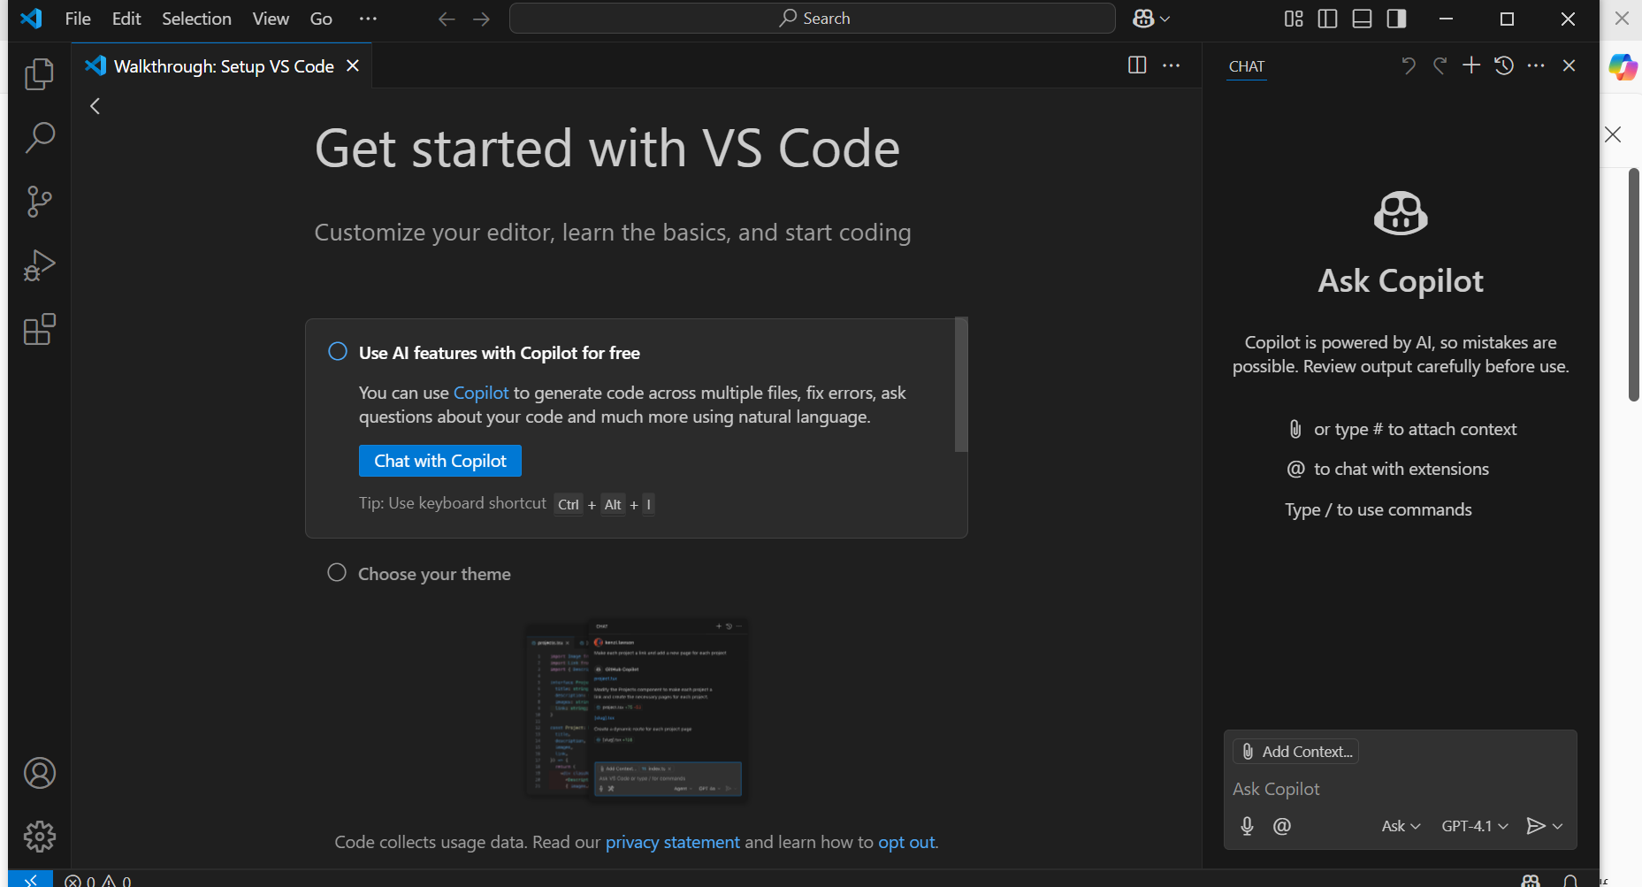

Thus you’ll be directed to your GitHub account to authorize CoPilot to work with your VSCode/GitHub account:

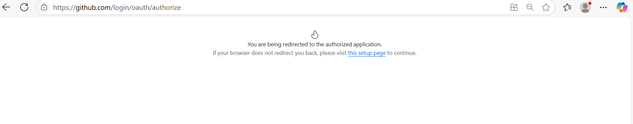
We have quite a few things to do:
- we need to install the correct extension within VS code to work with DBT
- we need to set up DBT core such that we can begin building a DBT project which connects to a test snowflake account/instance see: (https://docs.getdbt.com/docs/core/connect-data-platform/snowflake-setup and https://www.youtube.com/watch?v=ZbLzOgAMAwk )
- We need to create a DBT project which is expressly integrated with our snowflake account, I’ll call this our ‘DBT snowflake project’
- This test ‘DBT snowflake project’
- we need to integrate that ‘DBT snowflake project’ within a git repo in Azure dev ops so that the DBT project is in a main branch within dev ops and that branch becomes the ‘master branch’ for that DBT project
- Noting all the while that the connection parameters to the snowflake instance will likely need to be passed as parameters/stored as variables – possibly within azure devops (we will return to consider this point more later)
- we will need to test that team members can also (from an installed version of VS Code on their local machines) integrate the DBT project contained within Dev Ops and start creating branches, making changes and initiating Pull Requests via Dev Ops to make changes to the DBT code (which can be reviewed by developers)
- There is a further bit… namely creating Ci/Cd pipelines which will automatically integrate changes from Dev to Test and then (on approving the Pull Request) deploy the approved changes into Prod. This will mean that we’ll ultimately need a Dev, Test and Prod ‘environment’ which for us will likely just be separate databases within the same snowflake account (rather than separate snowflake instances/accounts). This ultimate aim of integration is captured in the image below:

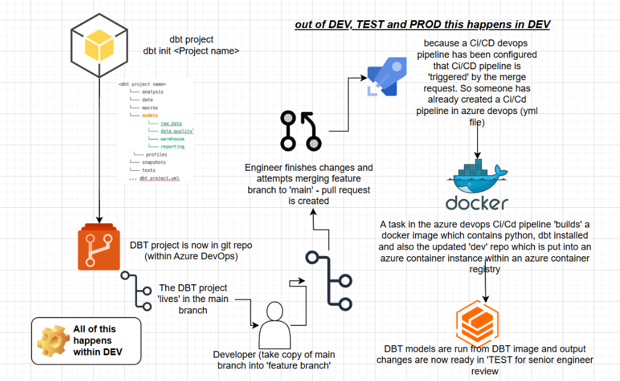
I ask Copilot if I can install DBT Core within VS code and Copilot tells me that I can by executing ‘pip install commands’ using a ‘terminal’ (command prompt) within VS Code:

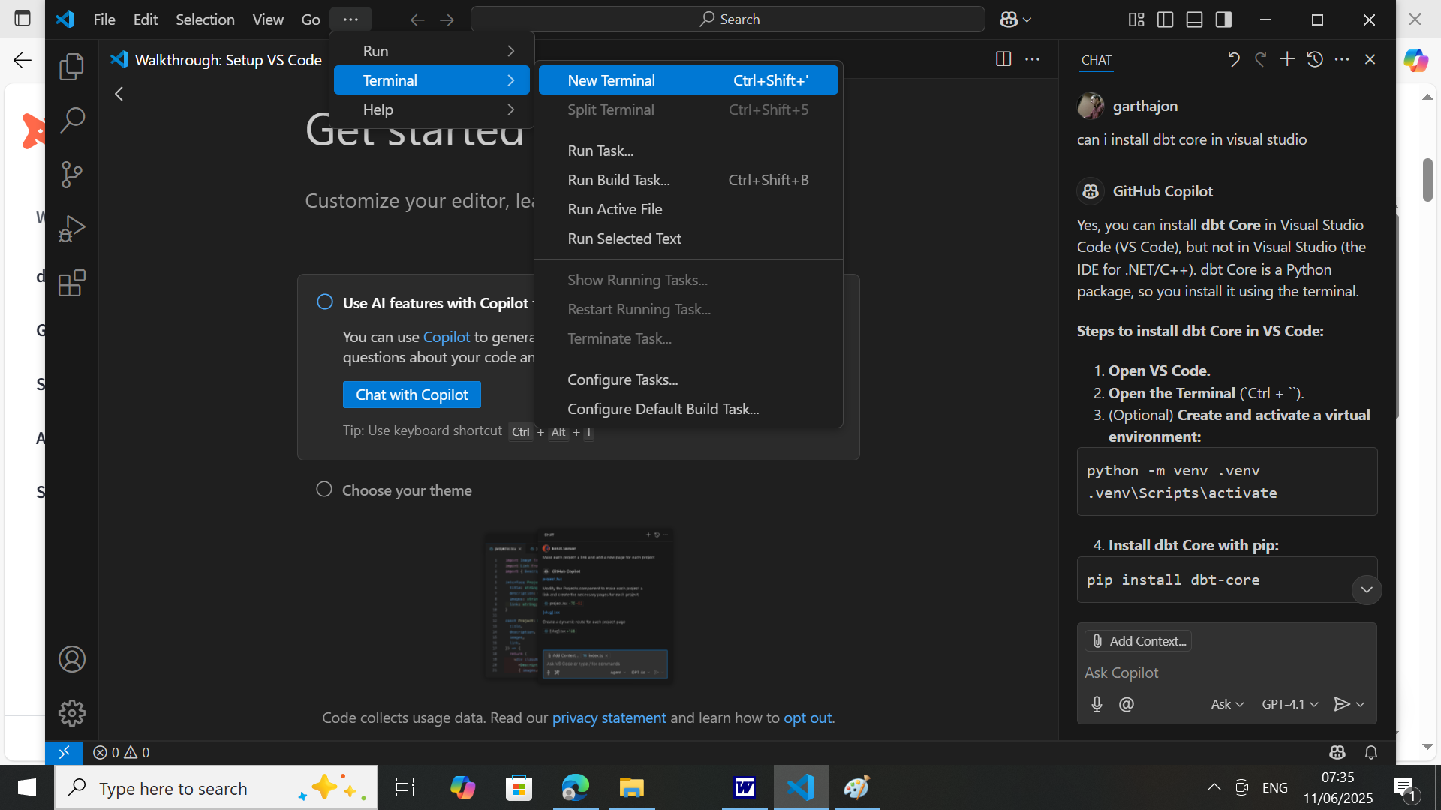

Referring to the DBT/snowflake set up documents on the actual DBT site (https://docs.getdbt.com/docs/core/connect-data-platform/snowflake-setup ) I get hold of the necessary command for installing DBT core for snowflake on my local machine and I open the terminal and execute the commands:

python -m pip install dbt-core dbt-snowflake

I receive an error, indicating that Python is not installed. Which is interesting, because I thought it was!

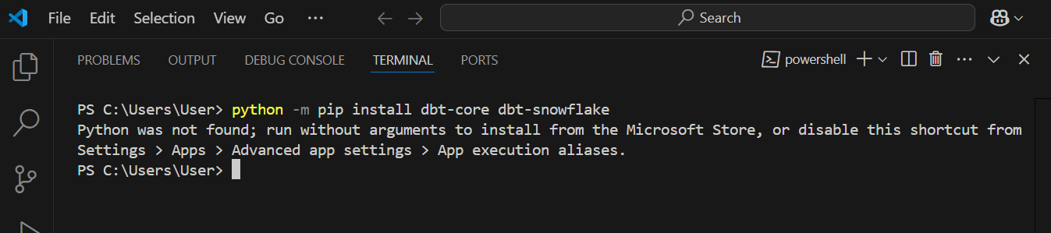

On checking the environment variables, I can see that there is a ‘roaming’ Python installation:
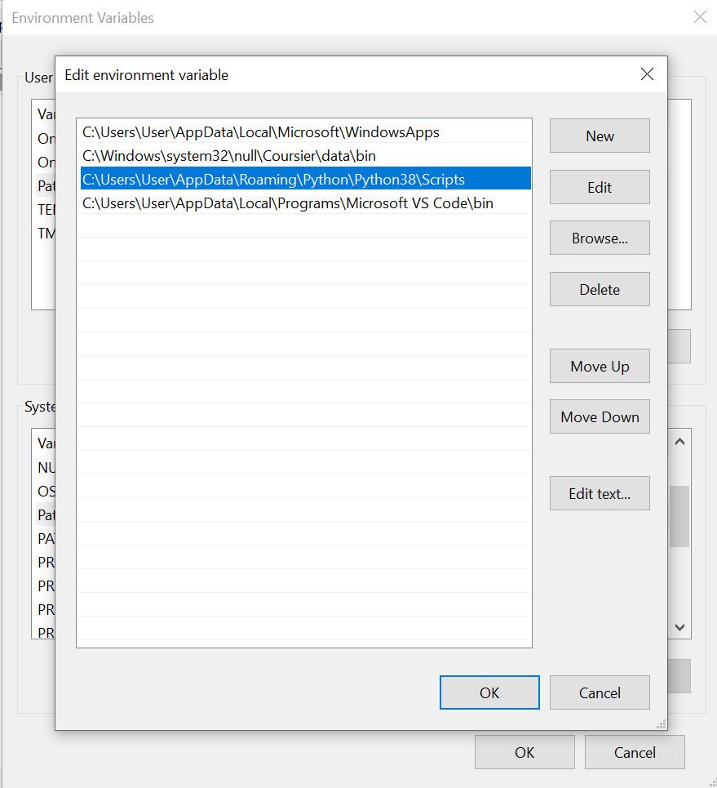

whereas I can see a ‘roaming’ profile. Since python commands are not working on the machine, I’m going to install Python afresh under the current user profile by downloading the official python installer from python.org:

https://www.python.org/downloads/windows/

on installing python I ticked the ‘use admin privileges option’ as apparently this allows ALL users on the machine to be able to access the python installation:

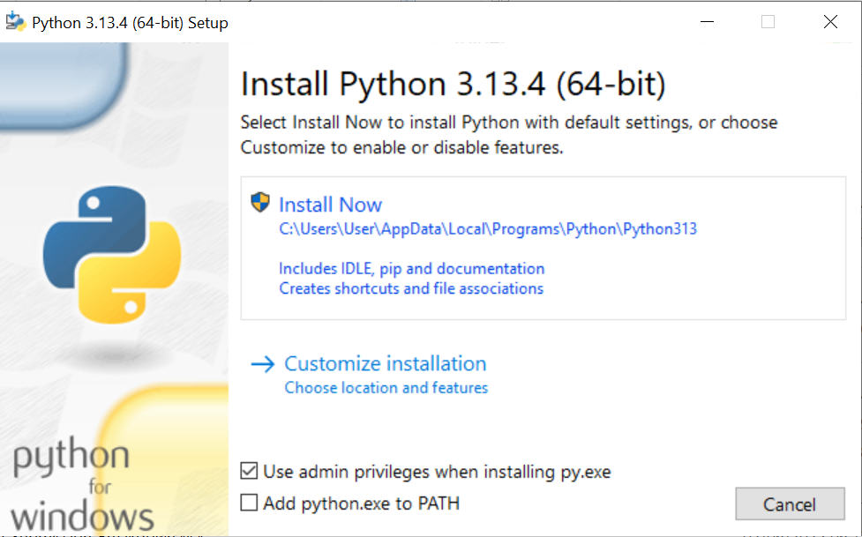

(note that I’m using the following guide for this installation: https://realpython.com/installing-python/ )

Unfortunately, even after installing the command is still not recognized, so by typing python in the search bar I locate where python was installed and add that path to the ‘path’ environment variable on my machine:

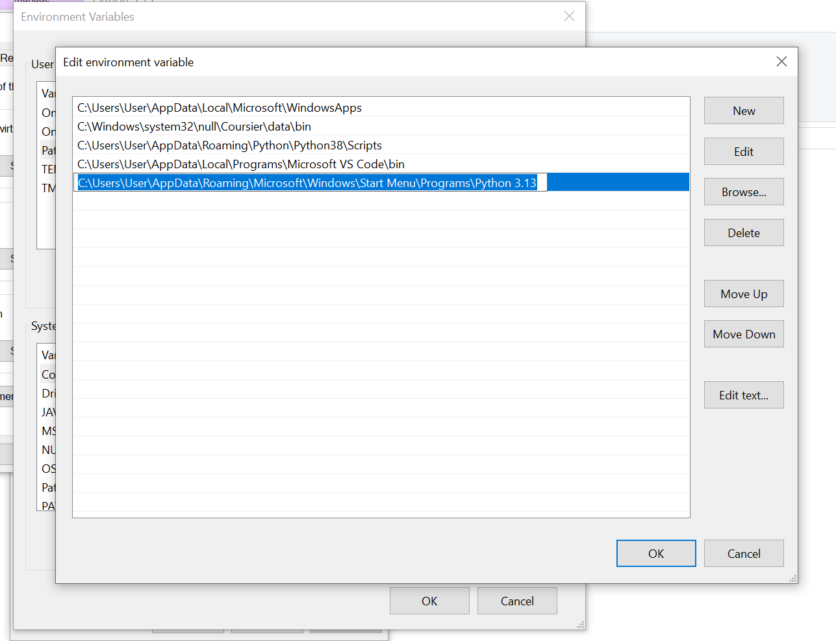

It still doesn’t work, and I think much of this is owing to the installation being at a local user level rather than at system level. A quick check with chatgpt reveals than on installation I need to ‘right click’ and install as administrator.

This time I go to advanced options and select ‘install for all users’ and ‘add path to environment variable’:

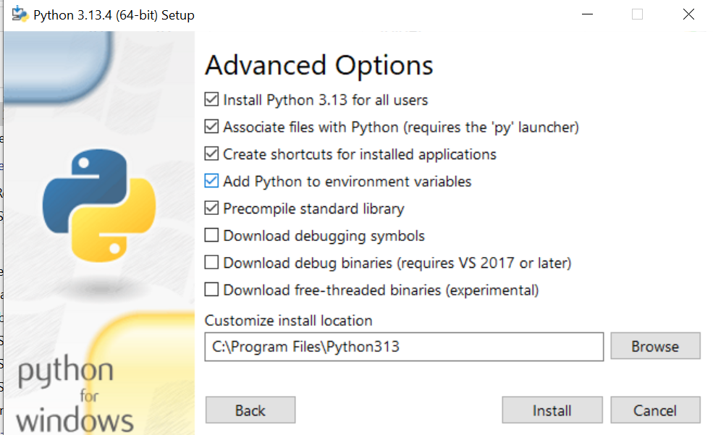

what a faff… further even this did not work, but then I note that on running the program in question as administrator THEN it worked. This is VERY odd because the current local account I am using IS an administrator:

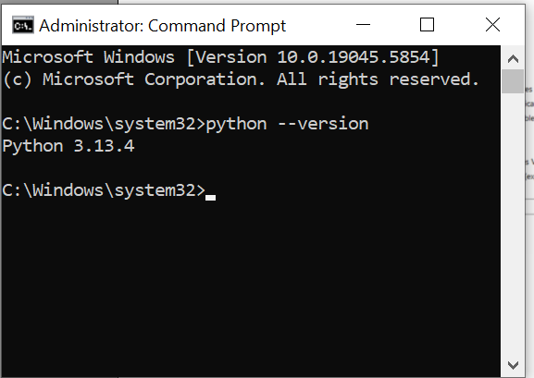

but this time, going back into VS code, and going back into the terminal (without even running the programme as administrator), it does recognize the installation of python:

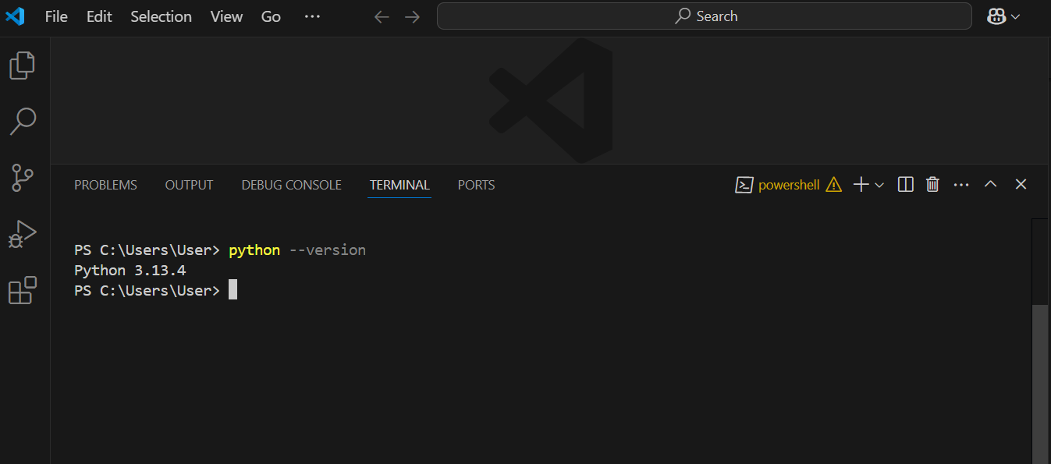

and this time the machine gets busy installing DBT core and the necessary snowflake connectors etc. python -m pip install dbt-core dbt-snowflake

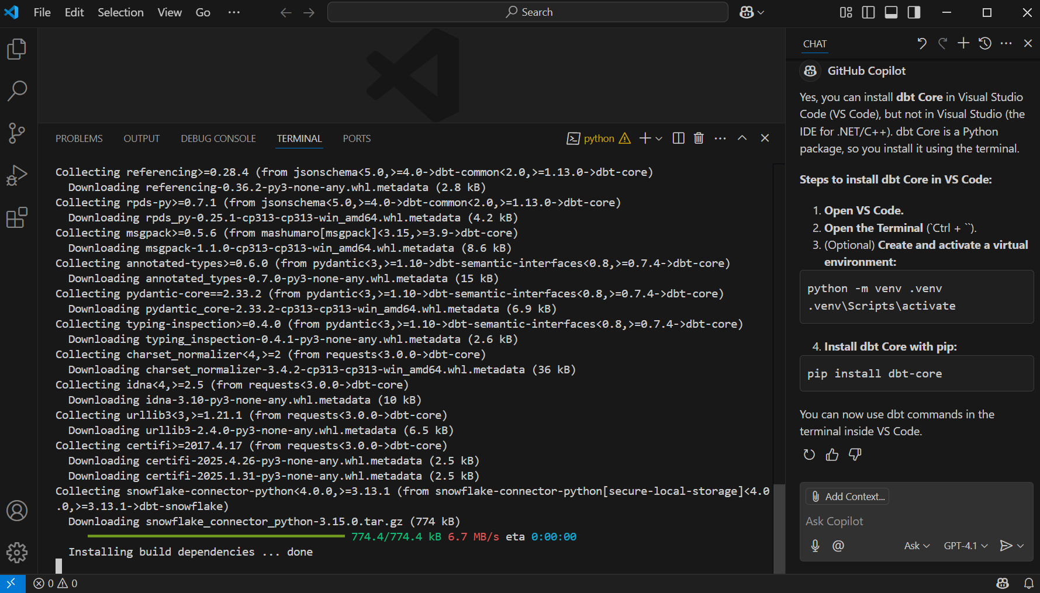

And I actually had another ‘cannot write to directory’ error, which I also obviated/resolved by closing VS code and re-opening explicitly as administrator. So this is all VERY odd because although the local profile which I am using states that I am an administrator, clearly – by default – the account is not automatically enabling basic set-up/administrator privileges and I’m having to explicitly open applications as an administrator (right click – open as administrator) to be able to do what I want to do and run what I want to run.

Lastly, I still had an error message (when installing the snowflake connector) which seems to have been resolved by issuing the following command:

pip install snowflake-connector-python --no-cache-dir --prefer-binary

that seemed to sort the snowflake connector installation issue…

Installing the DBT extension in VS Code

Next (in order to use DBT effectively within VS code) we need to install the DBT extension and this installation is covered in the official DBT documentation here:

https://docs.getdbt.com/docs/install-dbt-extension

and the key instruction is simply this:

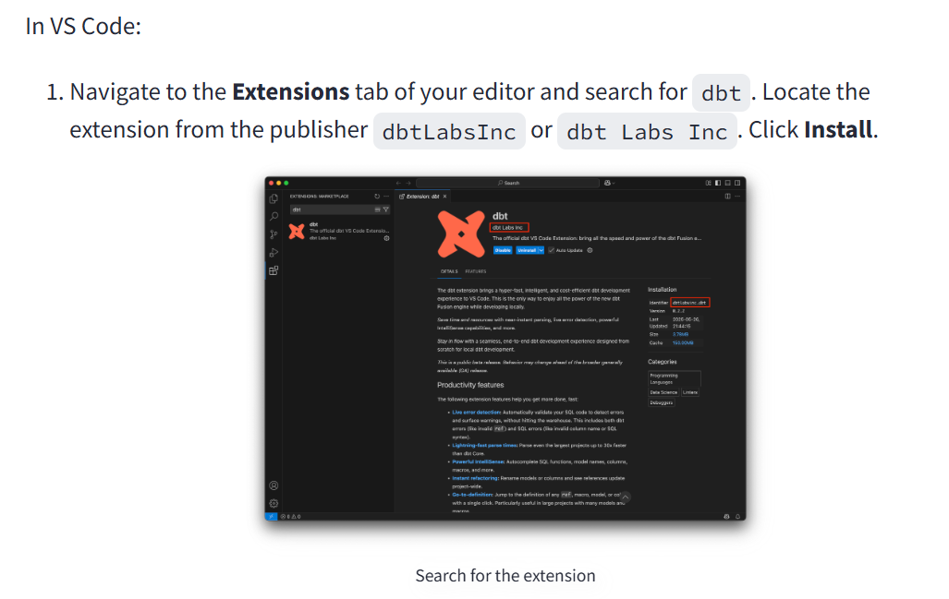

the installation is very fast but I now have the DBT extension installed within VS code see:

